# Version 1.1.24074.1 (06-20-24)

# Enhancements

* Updated UWP Certificate.

# Version 1.1.24074.1 (03-14-24)

# Enhancements

* Updated Serial Output Stream with Date and Time.

# Version 1.1.24038.1 (02-08-24)

# Enhancements

* Updated MQTT publish topics to include datavan side and datavan assetId.

Note - User should select datavan side with Datavan Config on Networking Screen as shown below.

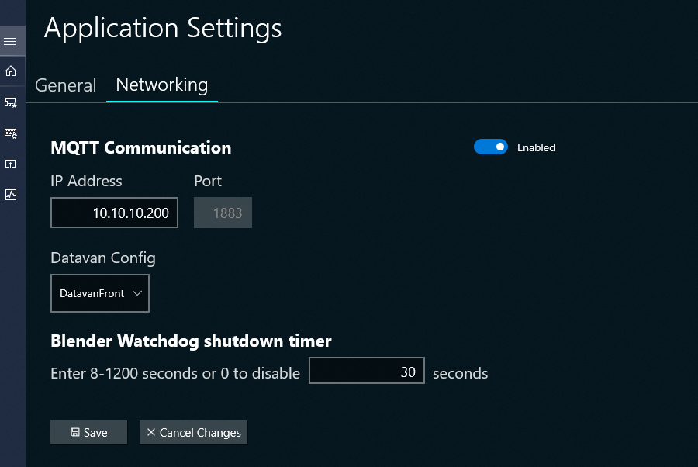

* Updated Chemicals Screen to retain chemical reordering on stage sync.
* Updated Pumping schedule to store and retain chemical concentration override.
* Updated MQTT LiveData topic to publish FeederId, FeederName and CombinedBaseRateTotal.
* Added performance improvements.
* Jobcenter publish JobName to MQTT.
* Updated BaseRate3 calculation to use Calculated-Suction-Rate or Measured-Suction-Rate based on selection on Chemical Suction Basis Rate from Application Setting Page

Measured Suction Rate uses SuctionRate(cleanrate)

Calculated Suction Rate uses CalculatedSuctionRate

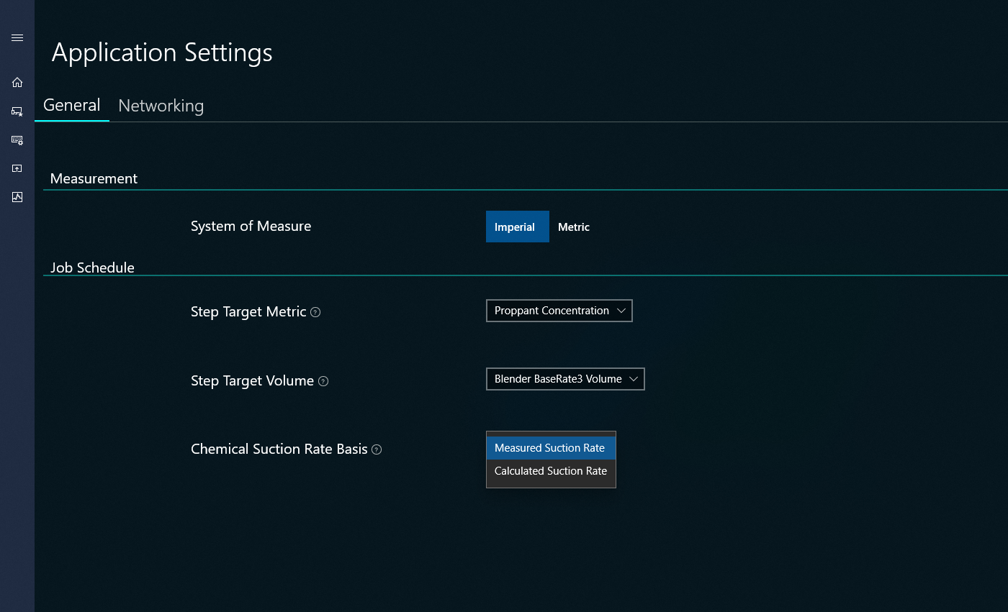

* Updated Process Controls Screen to retain Suction Rate Speed % when TubLevelMode is changed from Auto to Manual.
* Updated Process Controls Screen to retain Discharge Rate Speed % when Discharge Pressure Mode is updated from Auto to Manual.
* Updated MQTT reconnect logic to auto connect every 1 minute if connection is disconnected. Show warning if MQTT is disconnected.

# Bug Fixes

* Added fix for Chemical Screen not handling chemical type mismatch.

### This version is only compatible with the following firmware versions:

### AccuFrac Controller v6.0.0.5 or later

* Electric Blender AccuFrac HMI, X2 Extreme 12HP v6.0.0.2 or later
* AccuFrac Motor Controller v6.0.0.9 or later
* Electric Blender Motor Controller HMI, X2 Extreme 12HP v6.0.011 or later

This version is compatable with following software versions:

### IPC-PC v3.5.28 or later

### PMCS v1.1.31 or later

# Version 1.1.23298.3 (10-25-23)

# Enhancements

* Removed Burp Valve in Process Control Screen.
* Updated Process-Controls Screen with a dropdown under Auger’s section to select Augers base rate source.
* Updated Application Setting Screen-Job Schedule Section with ‘Blender Base Rate 3 Volume’ under step target volume.

# Bug Fixes

* Fixed EnableShunt sending the incorrect channel index.
* Fixed Remaining Step Volume calculation to use BaseRate3Total when staging on BaseRate3.
* Fixed CombinedBaseRate to populate when staging on BaseRate3 Volume.
* Fixed Pumping Schedule not retaining any new steps or changes.
* Note – When changing the StepTargetVolume to ‘Blender BaseRate3 Volume’ The Target BaseRate3 Volume(bbl) in Pumping Schedule should be manually entered.

### This version is only compatible with the following firmware versions:

### AccuFrac controller v6.0.0.0 or later

* Blender HMI, X2 Extreme 12HP v6.0.0.0 or later
* AccuFrac Motor controller v6.0.0.5 or later
* Electric Blender Motor controller HMI v6.0.0.6 or later